Lab9 Notes

Exerc. 1

Enable Synapse Link as per instructions, or the link Features. AFTER that you create the container. The labs was updated now. There is no mention about the missing In fact we can will simply ignore the UserProfileHTAP that appears in the screenshots.

Initially there is only one container: OnlineUserProfile01. You might add a second one: UserProfileHTAP, but we won’t use it anyway.

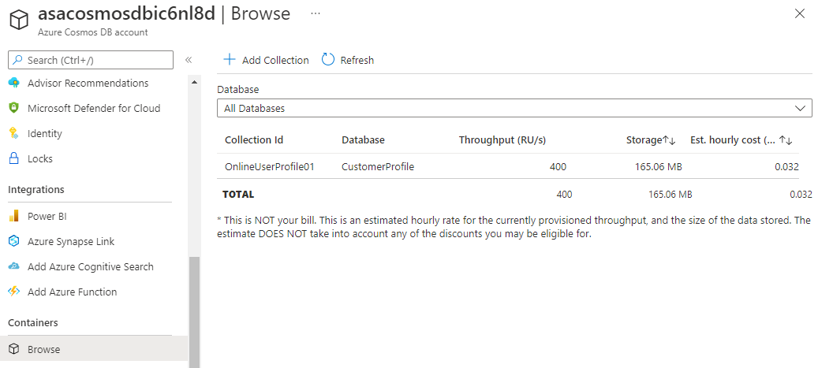

Click Add collection and add **UserProfileHTAP** to the existing database with partition key **/userId.** Enable analytical store.

It took quite a long time until I saw the below screen where I could enable Synapse Link for the OnlineUserProfile01. I didn’tenable at the time I tried the lab because we would copy data into the UserProfileHATP which is the only one that we would use to run analytics on! BUT task 2 at the end of exerc. 1 was removed and that task was the one that created a pipeline to copy the data from the OnlineUserProfile01 to UserProfileHTAP. Without this task we will have an empty analytical store that is useless. So, we should enable for the OnlineUserProfile01 and do all the following exercises with that one. Simply disregard the UserProfileHTAP  
The existing OnlineUserprofile01 would be for transactional access, not analytics (if task 2 were still there!)  
 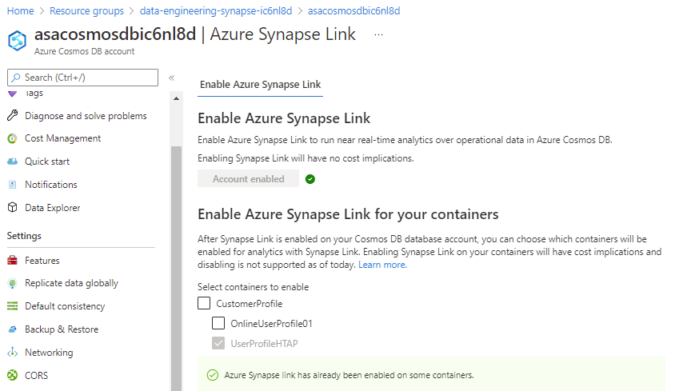

Now there is a NEXT button that will guide us through the creation of a LinkedService. We can ignore that one because we already have the linkedService. But for one of my students the linkedservice we had was not working and we did use that option to create one.

The screenshot below was taken before they removed task 2. It was a copy activity, copying all the documents from OnlineUserProfile01 to UserProfileHTAP.

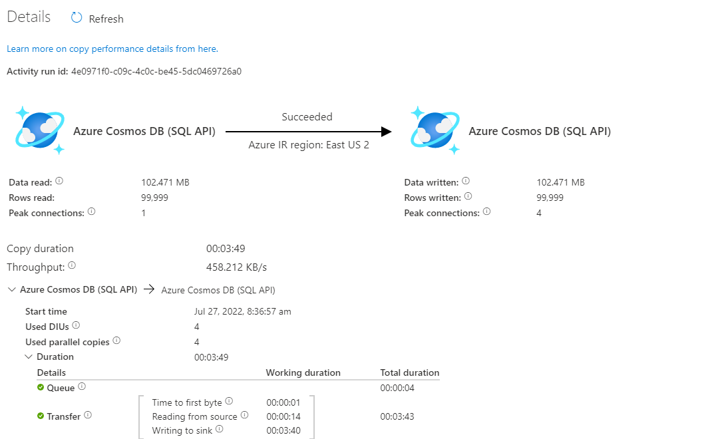

Exerc. 2

Fine, but make sure to replace UserProfileHTAP by OnlineUserProfile01 in the first cell and disregard any screenshots that still show UserProfileHTAP. For instance, you will right-click OnlineUserProfile01, but it is expected that we could enable analytical store for that container.

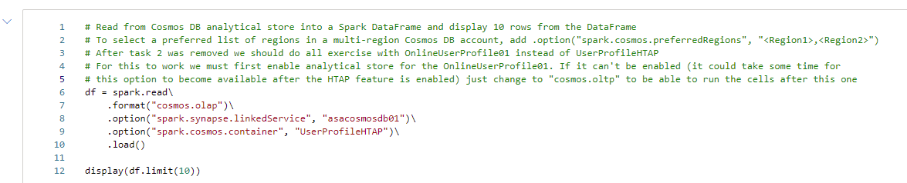

If we couldn’t enable, the choose New notebook > Load streaming DataFrame from container and modify readStream to read and keep only the first 2 options, so that it will match the cell above. Then all the following cells will run fine.

Exerc. 3

REQUIRES analytical store to be enabled.

